**DEPLOYMENT OF APP IN IBM CLOUD**

**Deploy in Kubernetes Cluster**

|  |  |
| --- | --- |
| TEAM ID | PNT2022TMID19795 |
| PROJECT NAME | Plasma Donor Application |

**Create a Kubernetes cluster**

* Sign in to your IBM cloud dashboard .
* Open **IBM Kubernetes Service**.

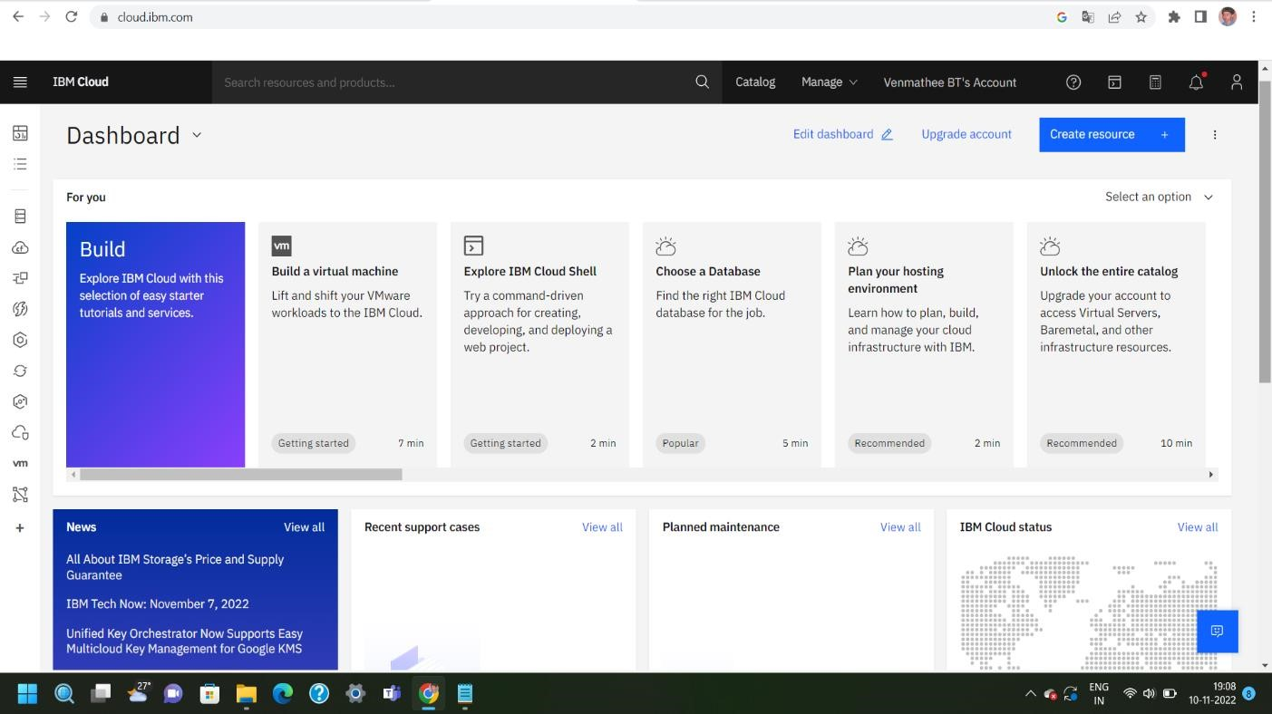

* Click **Create Cluster**.

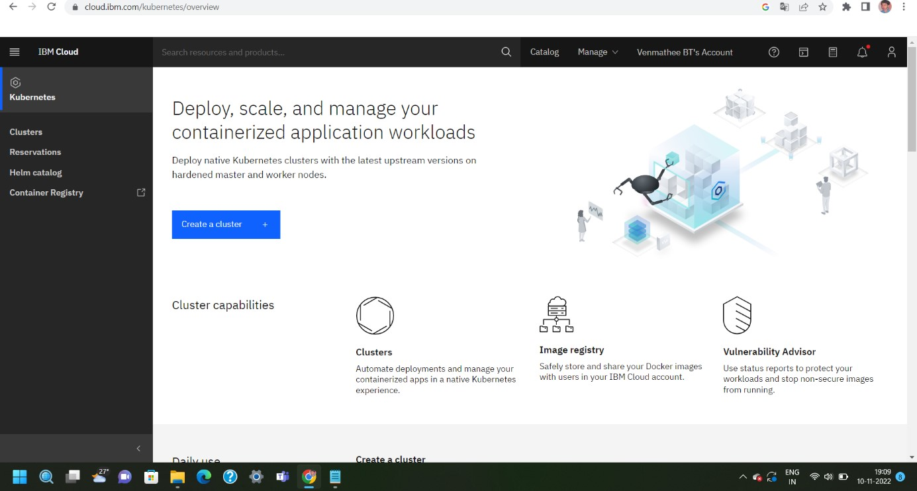

* Select the **Region** where you want to deploy the cluster, type in a **name** for your cluster, then click **Create Cluster**.
* Select the appropriate cluster type depending on your account.
* It takes some time for the cluster to get ready (around 30 minutes).

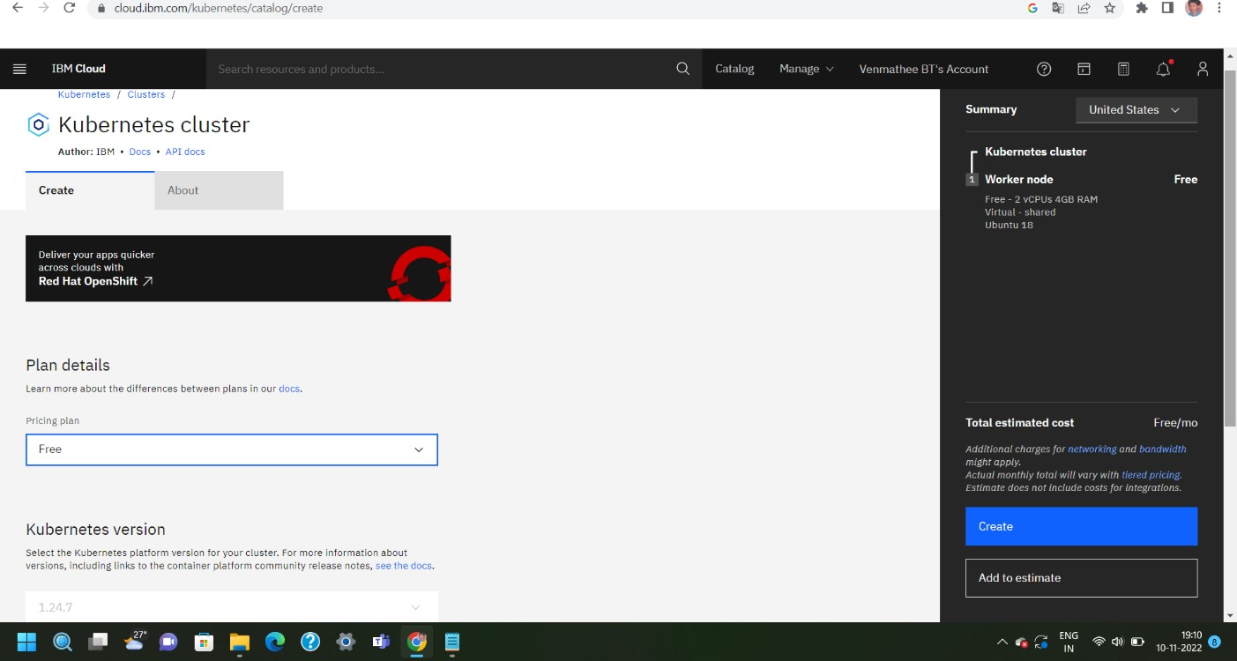

* Once the cluster is ready, click on your cluster's name and you will be redirected to a new page with information about your cluster and worker node.

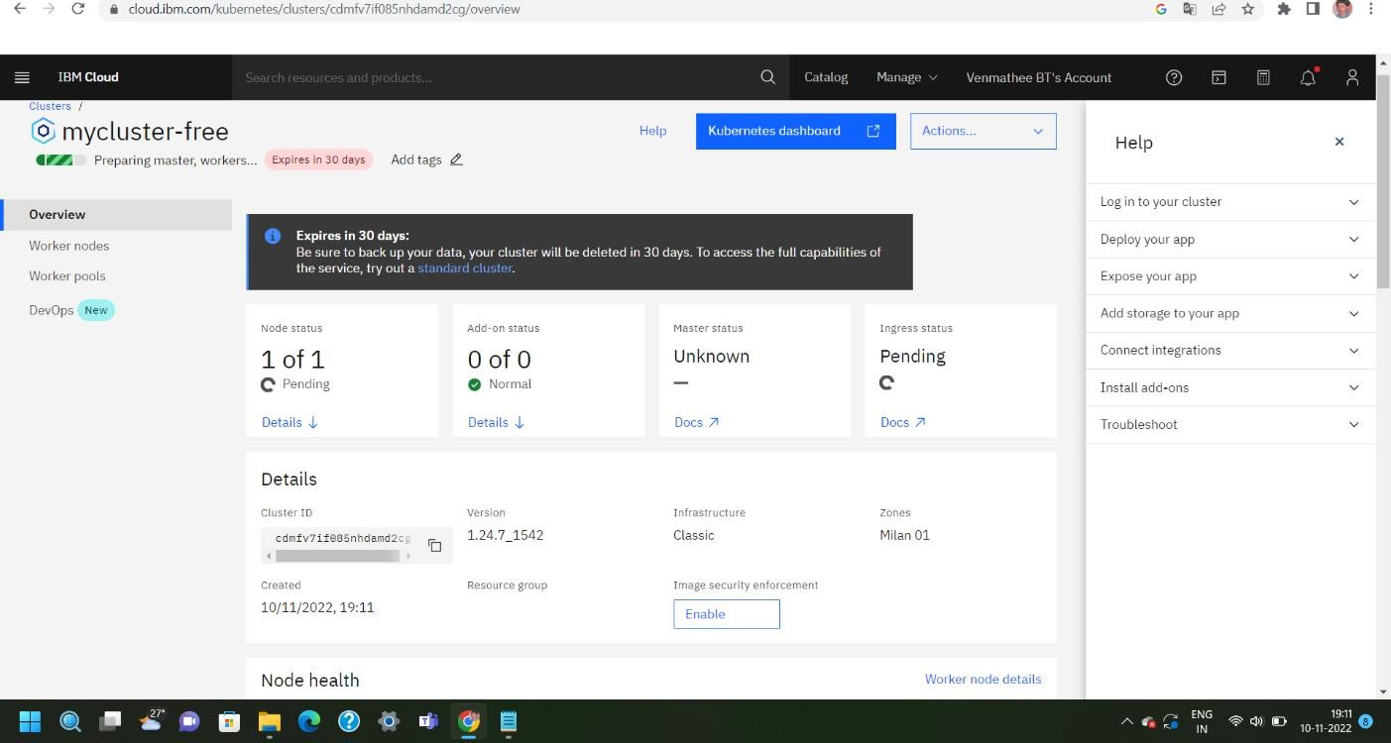

* Click on the **Worker Nodes** tab to note the cluster's Public IP.

